WEEK 1 : COGNIZANT DN 4.0 FSE HANDS-ON EXERCISES

Exercise 1: Implementing the Singleton Pattern
Logger.java
package singleton;
public class Logger
{
private static Logger instance;
private Logger()
{
System.out.println("Logger initialized...");
}
public static Logger getInstance()
{
if (instance == null)
{
instance = new Logger();
}
return instance;
}
public void log(String message)
{
System.out.println("[LOG] " + message);
}
}
LoggerTest.java
package singleton;
public class LoggerTest
{
public static void main(String[] args)
{
Logger logger1 = Logger.getInstance();
Logger logger2 = Logger.getInstance();
logger1.log("First log message");
logger2.log("Second log message");
if (logger1 == logger2)
{
System.out.println("Both logger instances are the same (Singleton works!)");
} else
{
System.out.println("Different logger instances (Singleton failed!)");
}
}
}
Output
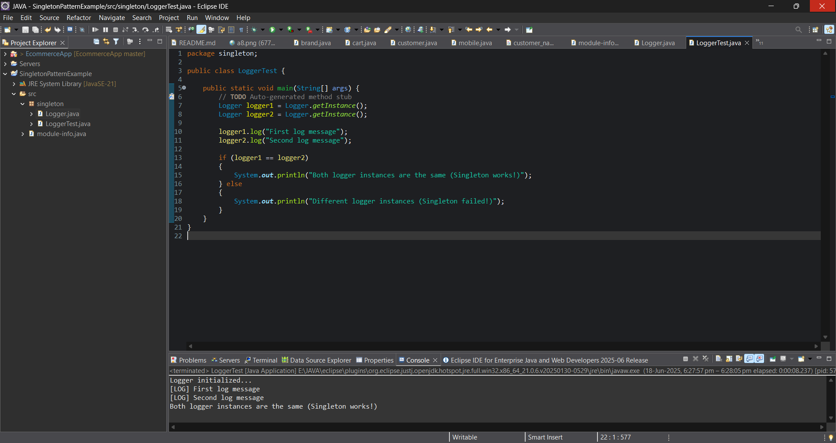

Exercise 2: Implementing the Factory Method Pattern

#Creating Interface
Document
public interface Document {
void open();
}

#Creating Concrete Document Classes
WordDocument.java
public class WordDocument implements Document
{
@Override
public void open()
{
System.out.println("Opening a Word document.");
}
}

PdfDocument.java
public class PdfDocument implements Document
{
@Override
public void open()
{
System.out.println("Opening a PDF document.");
}
}

ExcelDocument.java
public class ExcelDocument implements Document
{
@Override
public void open()
{
System.out.println("Opening an Excel document.");
}
}

#Creating Abstract Factory Class
DocumentFactory.java
public abstract class DocumentFactory
{
public abstract Document createDocument();
}

#Creating Concrete Factories
WordFactory.java
public class WordFactory extends DocumentFactory
{
@Override
public Document createDocument()
{
return new WordDocument();
}
}

PdfFactory.java
public class PdfFactory extends DocumentFactory {
@Override
public Document createDocument() {
return new PdfDocument();
}
}

ExcelFactory.java
public class ExcelFactory extends DocumentFactory
{
@Override
public Document createDocument()
{
return new ExcelDocument();
}
}

#Creating Test Class
Main.java
public class Main {
public static void main(String[] args) {
DocumentFactory wordFactory = new WordFactory();
Document wordDoc = wordFactory.createDocument();
wordDoc.open();

DocumentFactory pdfFactory = new PdfFactory();
Document pdfDoc = pdfFactory.createDocument();
pdfDoc.open();

DocumentFactory excelFactory = new ExcelFactory();
Document excelDoc = excelFactory.createDocument();
excelDoc.open();
}
}

Output
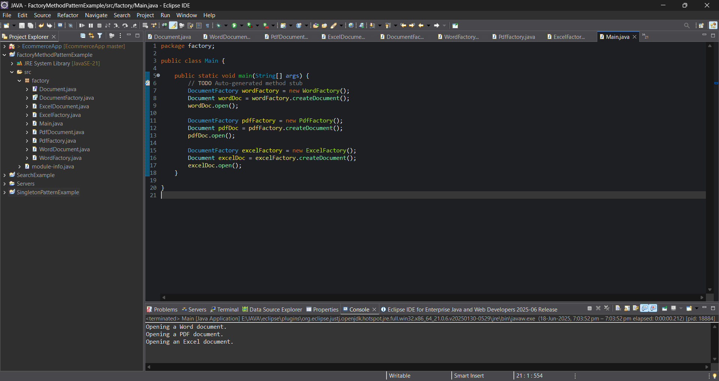

Exercise 3: E-commerce Platform Search Function
Product.java
package search;
public class Product
{
private int productId;
private String productName;
private String category;
public Product(int productId, String productName, String category)
{
this.productId = productId;
this.productName = productName;
this.category = category;
}
public int getProductId() {
return productId;
}
public String getProductName() {
return productName;
}
public String getCategory() {
return category;
}
}

SearchEngine.java
package search;
import java.util.Arrays;
public class SearchEngine
{
public static Product linearSearch(Product[] products, String name)
{
for (Product p : products)
{
if (p.getProductName().equalsIgnoreCase(name))
{
return p;
}
}
return null;
}
public static Product binarySearch(Product[] products, String name)
{
Arrays.sort(products, (a, b) -> a.getProductName().compareToIgnoreCase(b.getProductName()));
int low = 0;
int high = products.length - 1;
while (low <= high) {
int mid = (low + high) / 2;
int result = products[mid].getProductName().compareToIgnoreCase(name);
if (result == 0)
{
return products[mid];
}
else if (result < 0)
{
low = mid + 1;
}
else
{
high = mid - 1;
}
}
return null;
}
}
SearchTest.java
package search;
public class SearchTest
{
public static void main(String[] args) {
Product[] products = {
new Product(1, "Laptop", "Electronics"),
new Product(2, "Shoes", "Footwear"),
new Product(3, "Watch", "Accessories"),
new Product(4, "Mobile", "Electronics"),
new Product(5, "T-shirt", "Clothing")
};
String searchTerm = "Mobile";
System.out.println("Using Linear Search:");
Product result1 = SearchEngine.linearSearch(products, searchTerm);
printResult(result1);
System.out.println("\nUsing Binary Search:");
Product result2 = SearchEngine.binarySearch(products, searchTerm);
printResult(result2);
}
public static void printResult(Product product)
{
if (product != null)
{
System.out.println("Product Found: " + product.getProductName() + " in " + product.getCategory());
}
else
{
System.out.println("Product Not Found");
}
}
}

Output
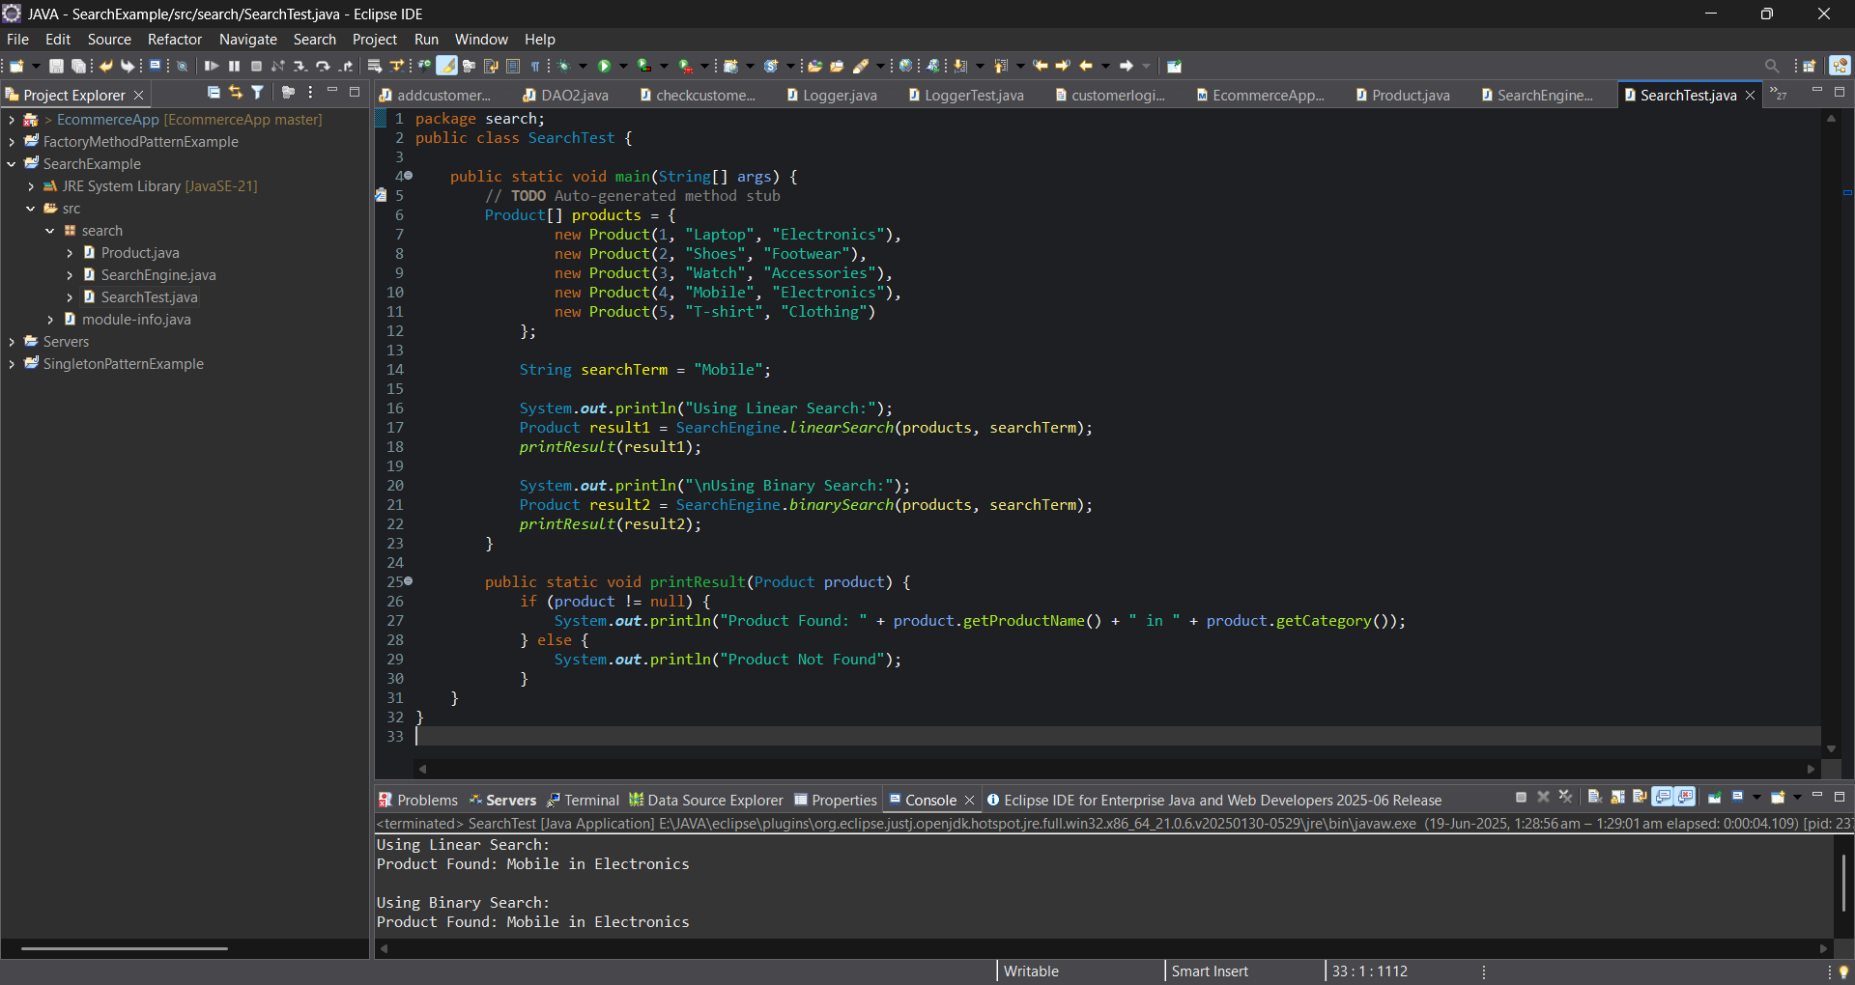

Exercise 4: Financial Forecasting

Forecast.java
package forecast;
public class Forecast
{
public static double calculateFutureValue(double currentValue, double growthRate, int years) {
if (years == 0)
{
return currentValue;
}
else
{
return calculateFutureValue(currentValue * (1 + growthRate), growthRate, years - 1);
}
}
public static void main(String[] args)
{
double initialValue = 10000.0;
double growthRate = 0.1;
int years = 5;
double futureValue = calculateFutureValue(initialValue, growthRate, years);
System.out.printf("The projected value after %d years is: ₹%.2f%n", years, futureValue);
}
}

Output
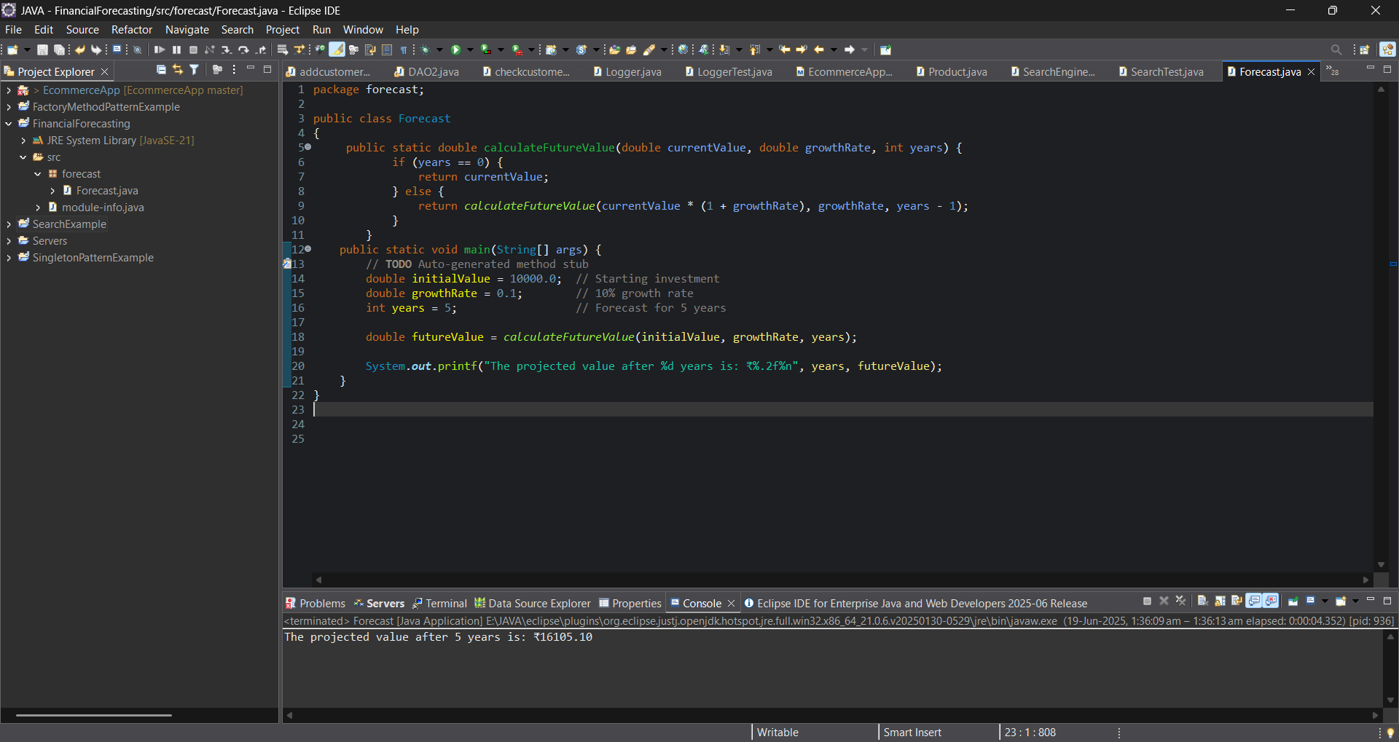
Exercise 5: Implementing the MVC Pattern

#Under model package
Student.java
package model;
public class Student {
private String id;
private String name;
private String grade;
public Student(String id, String name, String grade) {
this.id = id;
this.name = name;
this.grade = grade;
}
public String getId() {
return id;
}
public void setId(String id) {
this.id = id;
}
public String getName() {
return name;
}
public void setName(String name) {
this.name = name;
}
public String getGrade() {
return grade;
}
public void setGrade(String grade) {
this.grade = grade;
}
}

#Under view package
StudentView.java
package view;
import model.Student;
public class StudentView {
public void displayStudentDetails(Student student) {
System.out.println("---- Student Details ----");
System.out.println("ID : " + student.getId());
System.out.println("Name : " + student.getName());
System.out.println("Grade : " + student.getGrade());
System.out.println("-------------------------\n");
}
}

#Under Controller package
StudentController.java
package controller;
import model.Student;
import view.StudentView;
public class StudentController {
private Student model;
private StudentView view;
public StudentController(Student model, StudentView view) {
this.model = model;
this.view = view;
}
public String getStudentName() {
return model.getName();
}
public String getStudentId() {
return model.getId();
}
public String getStudentGrade() {
return model.getGrade();
}
public void setStudentName(String name) {
model.setName(name);
}
public void setStudentId(String id) {
model.setId(id);
}
public void setStudentGrade(String grade) {
model.setGrade(grade);
}
public void updateView() {
view.displayStudentDetails(model);
}
}

#Under Main package
Main.java
package main;
import model.Student;
import view.StudentView;
import controller.StudentController;
public class Main {
public static void main(String[] args) {
Student student = new Student("S101", "Alice", "A");
StudentView view = new StudentView();
StudentController controller = new StudentController(student, view);
controller.updateView();
controller.setStudentName("Alice Johnson");
controller.setStudentGrade("A+");
controller.updateView();
}
}

Output
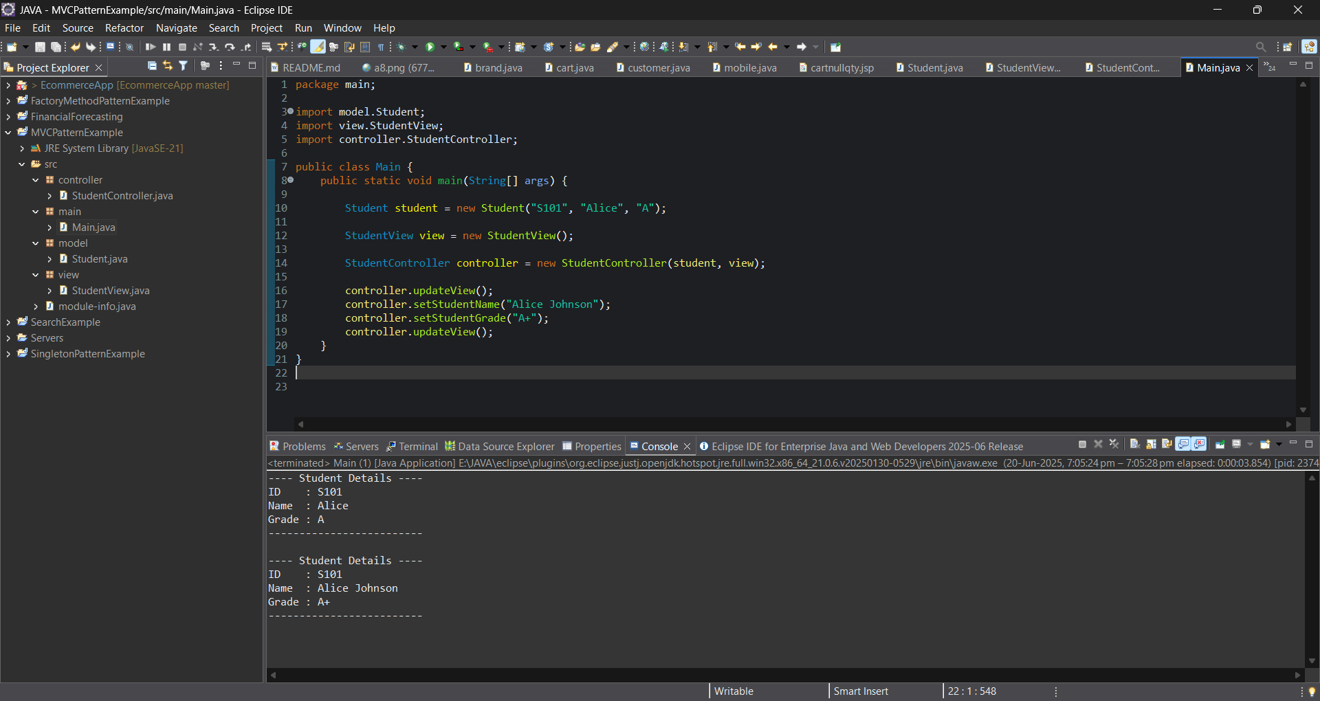

PL/SQL Exercise:
Exercise 1: Control Structures
Scenario 1: The bank wants to apply a discount to loan interest rates for customers above 60 years old.
o Question: Write a PL/SQL block that loops through all customers, checks their age, and if they are above 60, apply a 1% discount to their current loan interest rates.
Scenario 2: A customer can be promoted to VIP status based on their balance.
o Question: Write a PL/SQL block that iterates through all customers and sets a flag IsVIP to TRUE for those with a balance over $10,000.
Scenario 3: The bank wants to send reminders to customers whose loans are due within the next 30 days.
o Question: Write a PL/SQL block that fetches all loans due in the next 30 days and prints a reminder message for each customer
Scenario 1: Apply 1% Interest Discount

BEGIN
FOR cust_rec IN (
SELECT CustomerID, Name, DOB
FROM Customers
) LOOP
DECLARE
v_age NUMBER;
BEGIN
v_age := FLOOR(MONTHS_BETWEEN(SYSDATE, cust_rec.DOB) / 12);

IF v_age > 60 THEN
UPDATE Loans
SET InterestRate = InterestRate - 1
WHERE CustomerID = cust_rec.CustomerID;

DBMS_OUTPUT.PUT_LINE(
'Discount applied for customer: ' || cust_rec.Name
);
END IF;
END;
END LOOP;
END;
/

Scenario 2: Set VIP Status

BEGIN
FOR customer_rec IN (
SELECT CustomerID, Balance
FROM Customers
) LOOP

IF customer_rec.Balance > 10000 THEN
UPDATE Customers
SET IsVIP = 'TRUE'
WHERE CustomerID = customer_rec.CustomerID;
END IF;

END LOOP;

DBMS_OUTPUT.PUT_LINE('VIP status updated successfully.');

END;
/
Scenario 3: Loan Reminder
BEGIN
FOR loan_rec IN (
SELECT l.LoanID,
c.Name,
l.EndDate
FROM Loans l
JOIN Customers c
ON l.CustomerID = c.CustomerID
WHERE l.EndDate <= SYSDATE + 30
) LOOP

DBMS_OUTPUT.PUT_LINE(
'Reminder: Loan ID ' || loan_rec.LoanID ||
' for customer ' || loan_rec.Name ||
' is due on ' ||
TO_CHAR(loan_rec.EndDate,'DD-MON-YYYY')
);

END LOOP;
END;
/
OUTPUT
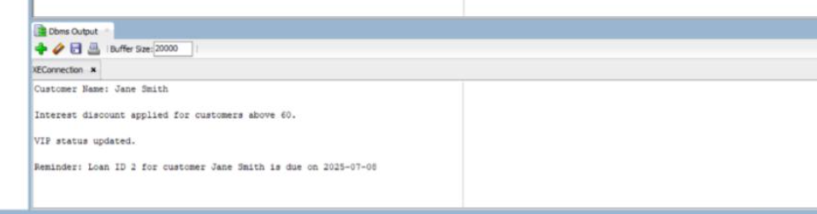

Exercise 3: Stored Procedures

Scenario 1: The bank needs to process monthly interest for all savings accounts.
o Question: Write a stored procedure ProcessMonthlyInterest that calculates and updates the balance of all savings accounts by applying an interest rate of 1% to the current balance.
Scenario 2: The bank wants to implement a bonus scheme for employees based on their performance.
o Question: Write a stored procedure UpdateEmployeeBonus that updates the salary of employees in a given department by adding a bonus percentage passed as a parameter.
Scenario 3: Customers should be able to transfer funds between their accounts.
o Question: Write a stored procedure TransferFunds that transfers a specified amount from one account to another, checking that the source account has sufficient balance before making the transfer

Solution:
Scenario 1: ProcessMonthlyInterest Procedure

CREATE OR REPLACE PROCEDURE ProcessMonthlyInterest IS
BEGIN
UPDATE Accounts
SET Balance = Balance + (Balance * 0.01)
WHERE AccountType = 'Savings';
DBMS_OUTPUT.PUT_LINE('Monthly interest applied to savings accounts.');
END;
/
BEGIN
ProcessMonthlyInterest;
END;
/
Scenario 2: UpdateEmployeeBonus Procedure

CREATE OR REPLACE PROCEDURE UpdateEmployeeBonus (
p_Department IN VARCHAR2,
p_BonusPercent IN NUMBER
) IS
BEGIN
UPDATE Employees
SET Salary = Salary + (Salary * (p_BonusPercent / 100))
WHERE Department = p_Department;
DBMS_OUTPUT.PUT_LINE('Bonus applied to department: ' || p_Department);
END;
/
Scenario 3: TransferFunds Procedure

CREATE OR REPLACE PROCEDURE TransferFunds (
p_SourceAccount IN NUMBER,
p_TargetAccount IN NUMBER,
p_Amount IN NUMBER
) IS
v_SourceBalance NUMBER;
BEGIN
SELECT Balance INTO v_SourceBalance
FROM Accounts
WHERE AccountID = p_SourceAccount;
IF v_SourceBalance < p_Amount THEN
RAISE_APPLICATION_ERROR(-20001, 'Insufficient balance.');
END IF;
UPDATE Accounts
SET Balance = Balance - p_Amount
WHERE AccountID = p_SourceAccount;
UPDATE Accounts
SET Balance = Balance + p_Amount
WHERE AccountID = p_TargetAccount;
DBMS_OUTPUT.PUT_LINE('Transfer completed.');
END;
/
BEGIN
TransferFunds(1, 2, 200);
END;

OUTPUT:
.
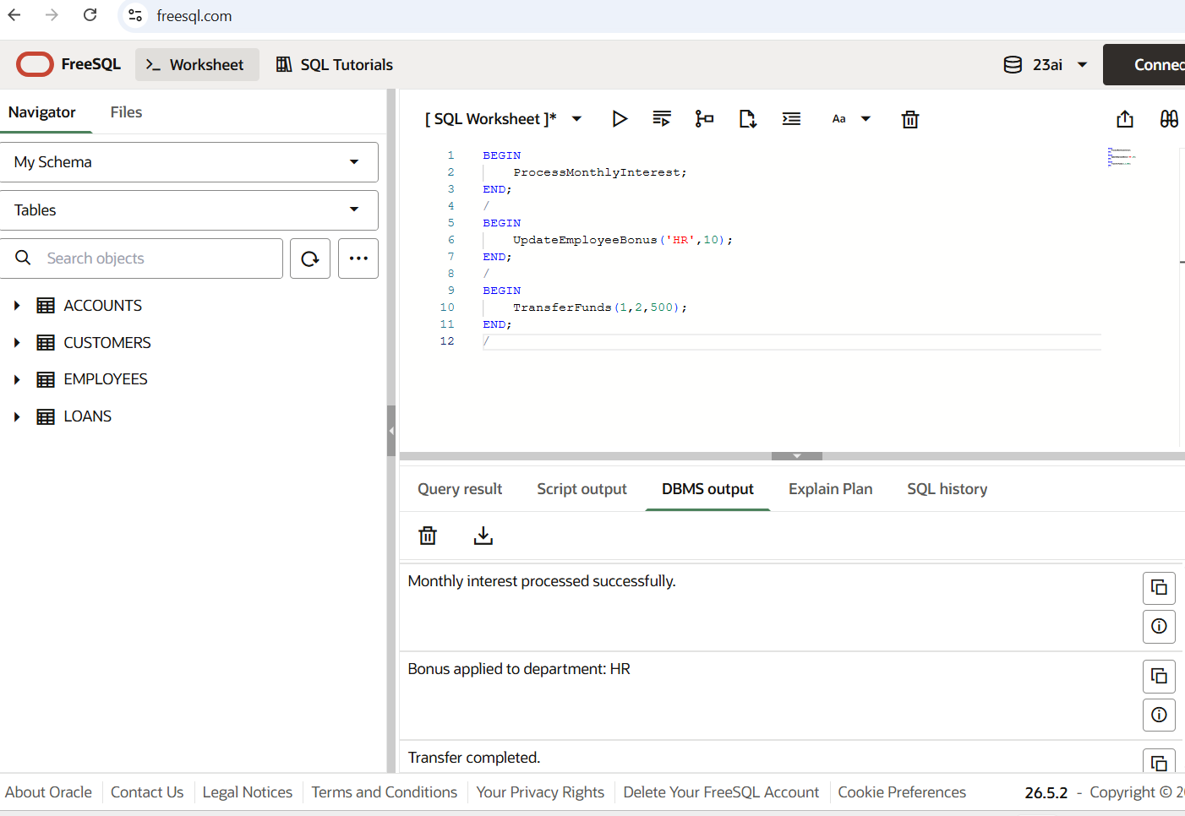

v JUnit Testing Exercises:

Exercise 1: Setting Up JUnit
Scenario:
You need to set up JUnit in your Java project to start writing unit tests.
Steps:
1. Create a new Java project in your IDE (e.g., IntelliJ IDEA, Eclipse).
2. Add JUnit dependency to your project. If you are using Maven, add the following to your pom.xml:
<dependency>
<groupId>junit</groupId>
<artifactId>junit</artifactId>
<version>4.13.2</version>
<scope>test</scope>
</dependency>
3.Create a new test class in your project.

Solution:

Calculator.java
package com.example;
public class Calculator {
public int add(int a, int b)
{
return a + b;
}
public int subtract(int a, int b) {
return a - b;
}
}

CalculatorTest.java
package com.example;
import org.junit.Test;
import static org.junit.Assert.*;
public class CalculatorTest
{
@Test public void testAdd()
{
Calculator calc = new Calculator();
int result = calc.add(2, 3);
assertEquals(5, result);
}
@Test public void testSubtract()
{
Calculator calc = new Calculator();
int result = calc.subtract(5, 3);
assertEquals(2, result);
}
}

OUTPUT

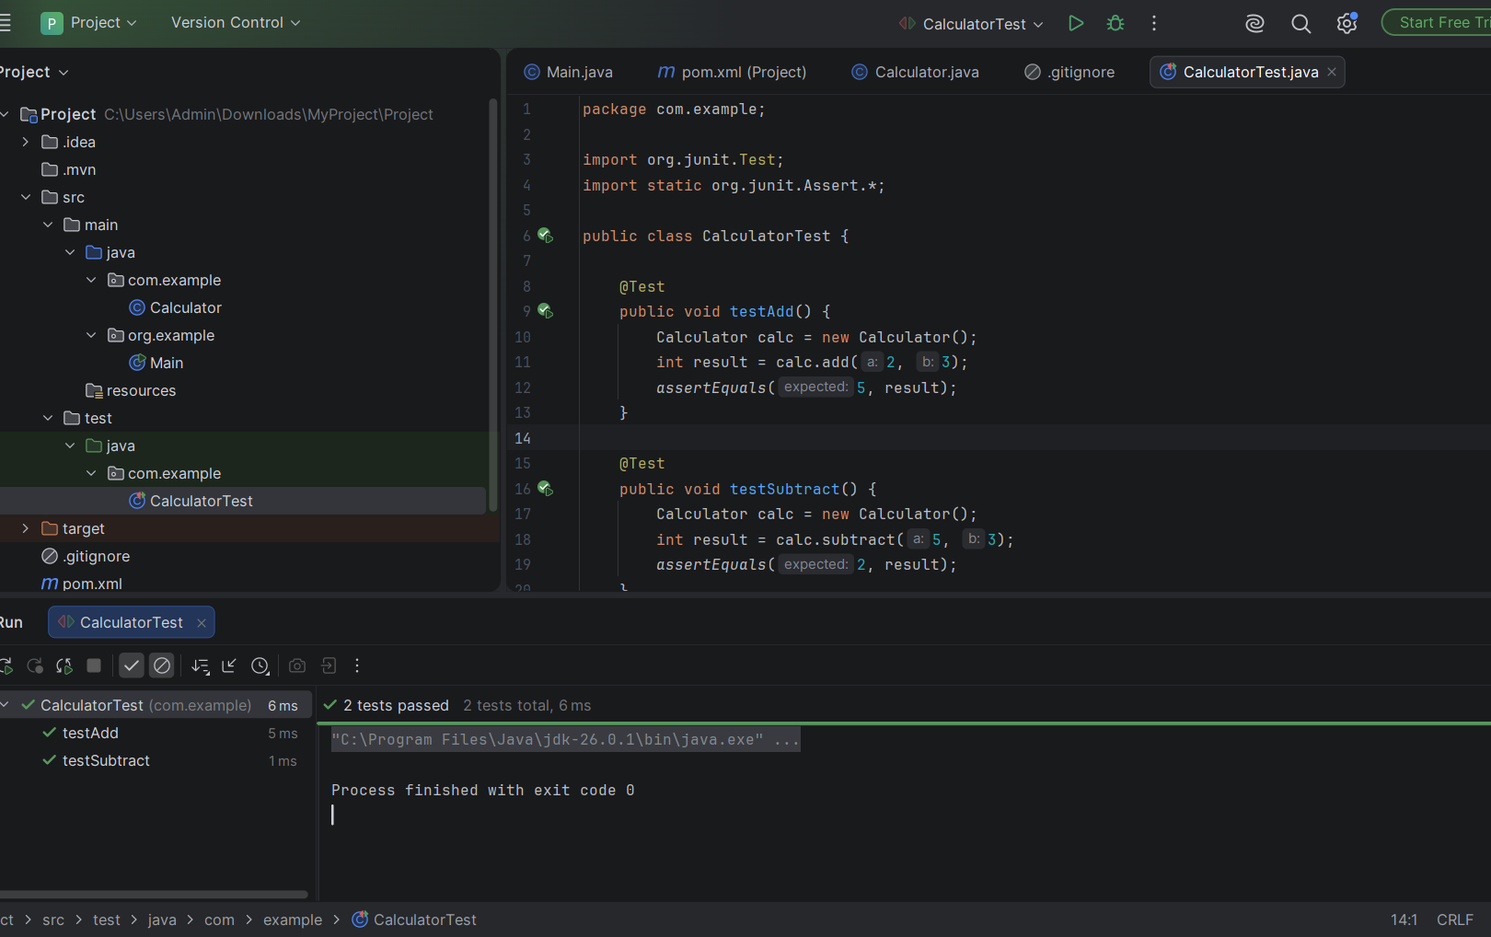

Exercise 3: Assertions in Junit
Scenario:
You need to use different assertions in JUnit to validate your test results.
Steps:
- Write tests using various JUnit assertions.

Solution:
AssertionsTest.java

package com.example;

import org.junit.Test;
import static org.junit.Assert.*;

public class AssertionsTest {

@Test
public void testAssertions() {

assertEquals(5, 2 + 3);

assertTrue(5 > 3);

assertFalse(5 < 3);

assertNull(null);

assertNotNull(new Object());
}
}
Output
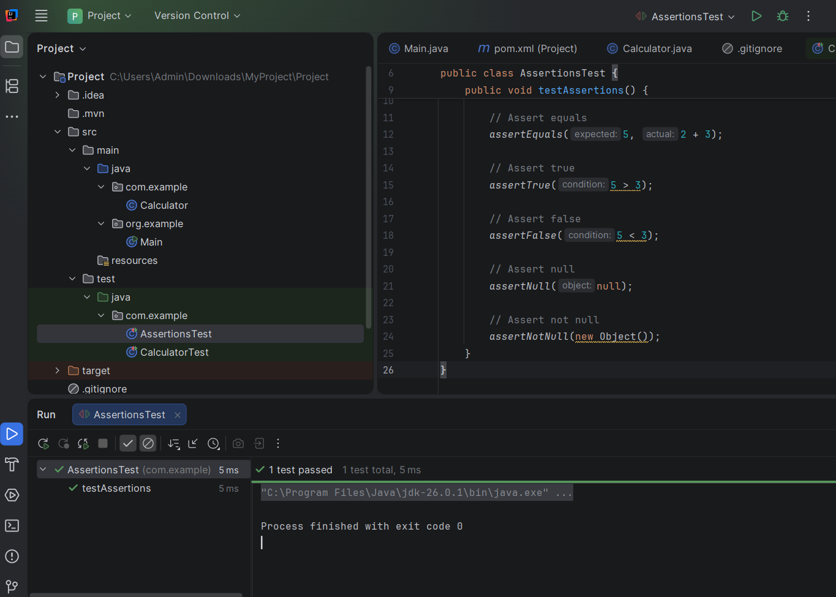

Exercise 4: Arrange-Act-Assert (AAA) Pattern, Test Fixtures, Setup and Teardown Methods in JUnit
Scenario:
You need to organize your tests using the Arrange-Act-Assert (AAA) pattern and use setup and teardown methods.
Steps:
1. Write tests using the AAA pattern.
2. Use @Before and @After annotations for setup and teardown methods.

SOLUTION:
CalculatorAaTest.java

package com.example;
import org.junit.After;
import org.junit.Before;
import org.junit.Test;
import static org.junit.Assert.*;
public class CalculatorAaTest {
private Calculator calculator;
@Before
public void setUp() {
calculator = new Calculator();
System.out.println("Setting up Calculator");
}
@After
public void tearDown() {
System.out.println("Tearing down");
}
@Test
public void testAddUsingAAA() {
int a = 2;
int b = 3;
int result = calculator.add(a, b);
assertEquals(5, result);
}
@Test
public void testSubtractUsingAAA() {
int a = 10;
int b = 4;
int result = calculator.subtract(a, b);
assertEquals(6, result);
}
}
OUTPUT
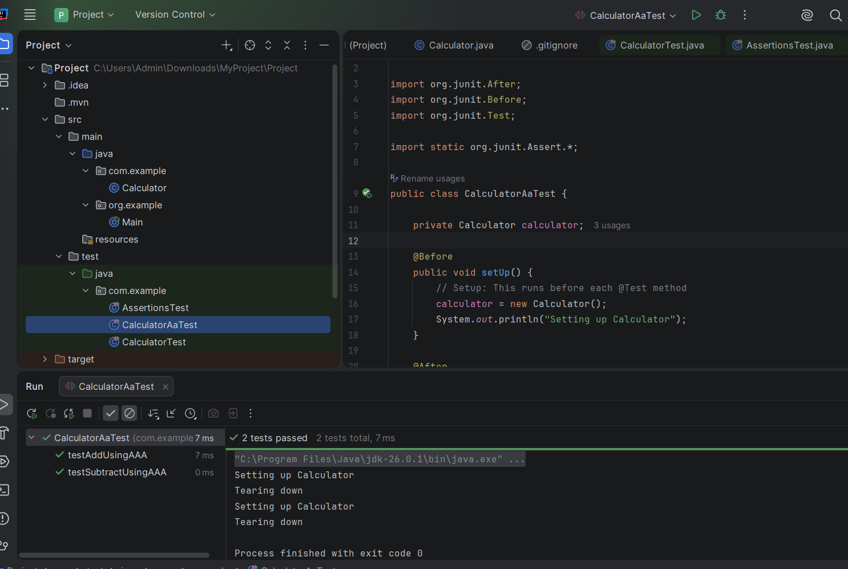

Exercise 1: Mocking and Stubbing
Scenario:
You need to test a service that depends on an external API. Use Mockito to mock the external API and stub its methods.
Steps:
1. Create a mock object for the external API.
2. Stub the methods to return predefined values.
3. Write a test case that uses the mock object.

ExternalApi.java
package com.example;

public interface ExternalApi {
String getData();
}

MyService.java

package com.example;

public class MyService {

private ExternalApi api;

public MyService(ExternalApi api) {
this.api = api;
}

public String fetchData() {
return api.getData();
}
}

MyServiceTest.java

package com.example;

import org.junit.Test;
import org.mockito.Mockito;

import static org.junit.Assert.*;
import static org.mockito.Mockito.*;

public class MyServiceTest {

@Test
public void testExternalApi() {

ExternalApi mockApi = Mockito.mock(ExternalApi.class);
when(mockApi.getData()).thenReturn("Mock Data");

MyService service = new MyService(mockApi);
String result = service.fetchData();

assertEquals("Mock Data", result);
}
}

OUTPUT:

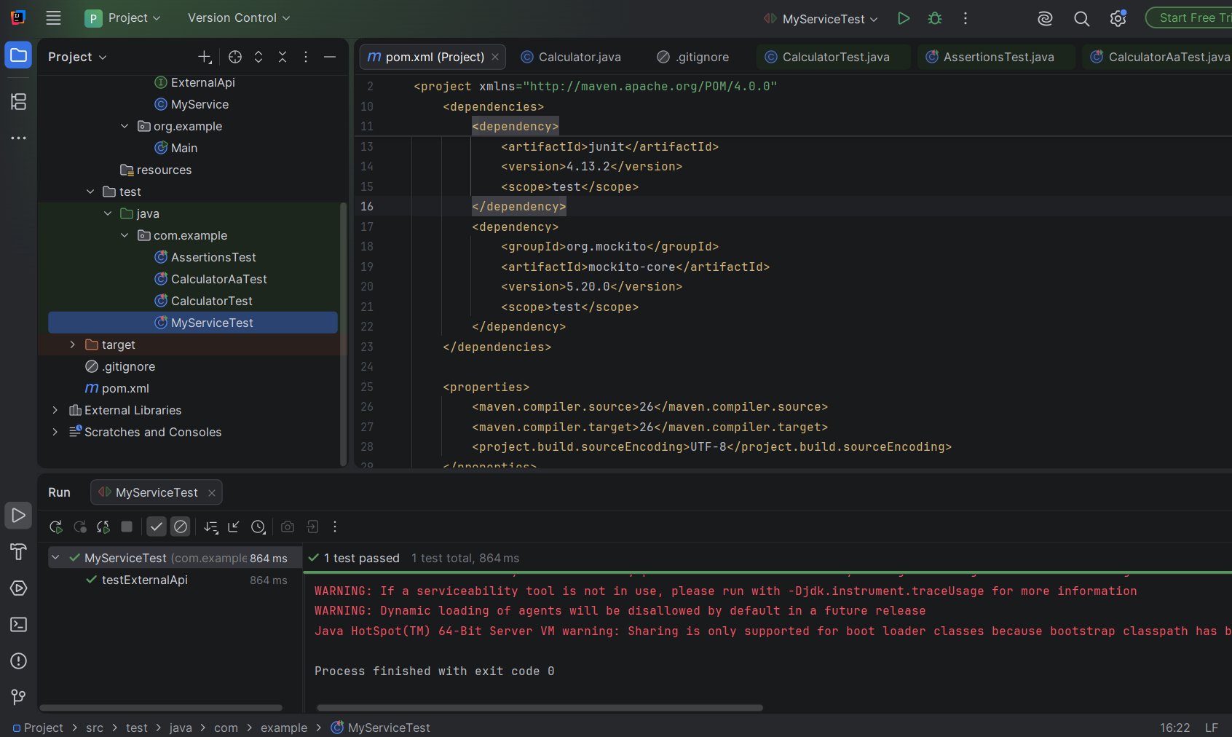

Exercise 2: Verifying Interactions
Scenario:
You need to ensure that a method is called with specific arguments.
Steps:
1. Create a mock object.
2. Call the method with specific arguments.
3. Verify the interaction.

MyServiceVerifyTest.java

package com.example;

import static org.mockito.Mockito.*;

import org.junit.Test;
import org.mockito.Mockito;

public class MyServiceVerifyTest {

@Test
public void testVerifyInteraction() {
ExternalApi mockApi = Mockito.mock(ExternalApi.class);
MyService service = new MyService(mockApi);

service.fetchData();
verify(mockApi).getData();
}
}

OUTPUT

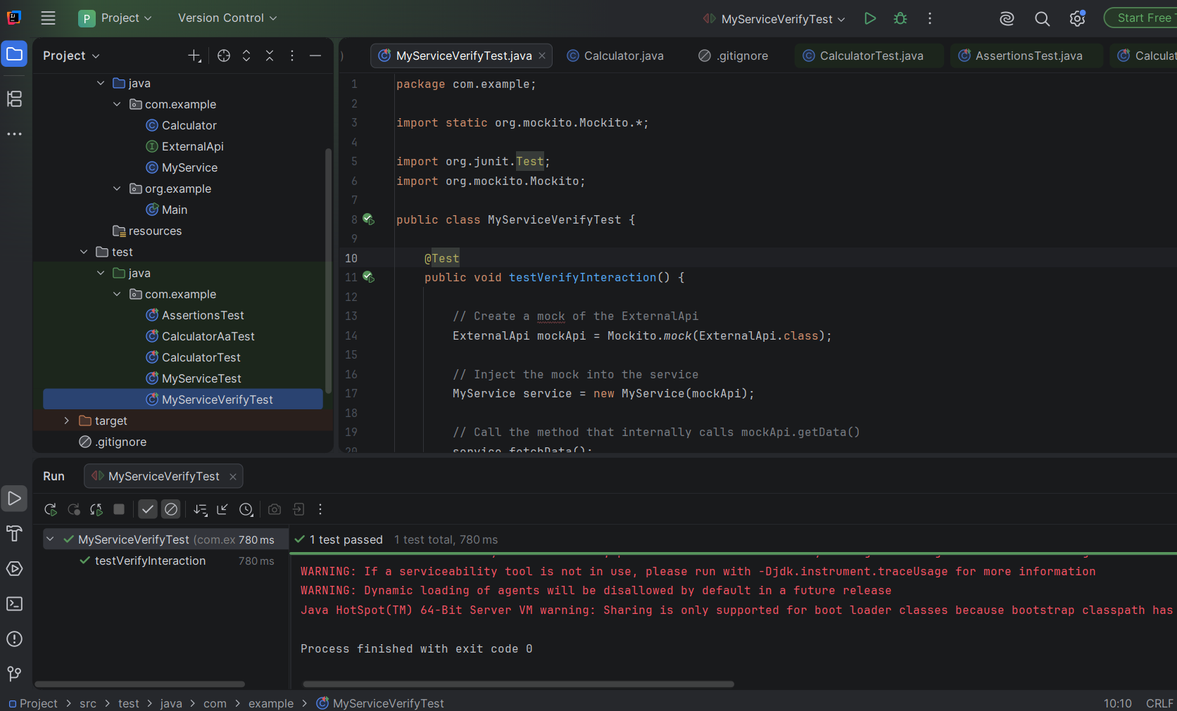

v Logging using SLF4J:

Exercise 1: Logging Error Messages and Warning Levels
Task:
Write a Java application that demonstrates logging error messages and warning levels using SLF4J.
Solution:

LoggingExample.java

package com.example;

import org.slf4j.Logger;
import org.slf4j.LoggerFactory;

public class LoggingExample {

private static final Logger logger = LoggerFactory.getLogger(LoggingExample.class);

public static void main(String[] args) {

logger.error("This is an error message");

logger.warn("This is a warning message");
}
}

OUTPUT


